Reading Outline for Plotnik’s Introduction to Psychology, 4th Edition
Module 4 “Incredible Nervous System”

Introduction
How do brains differ?
Jason’s Brain: An Error in Instructions
-
-
Lucy’s Brain: Perhaps the Beginning
-
-
Steve’s Brain: A Cruel Twist of Fate
-
-
Baby Theresa’s Brain: A Fatal Problem
-
-
- Genes & Evolution
1. Fertilization
-
-
2. Zygote
-
-
3. Chromosomes
-
-
-
4. Chemical alphabet
-
-
-
6. Fragile X syndrome
-
-
Evolution and the Human Brain
Charles Darwin –
Theory of Evolution –
-
Why did skulls grow in size?
Lucy’s Brain: Perhaps the Beginning
-
-
-
Homo erectus
-
-
-

Homo sapiens
-
-
-
B. Studying the Living Brain
New Techniques
-
-
CAT Scans –

MRI Scans –
-
-
PET Scans –
-
-
C. Organization of the Brain
Divisions of the Nervous System
-
1. Two Divisions of the Nervous System
Peripheral Nervous System
-
-
Central Nervous System
-
-
2. Two Subdivisions of Peripheral Nervous System
Somatic Nervous System
-
-
-
Autonomic Nervous System
-
-
3. Two Subdivisions of Autonomic Nervous System
Sympathetic Division
-
-
Parasympathetic
-
-
What Are the Three Major Parts of the Brain?
- Forebrain
-
-
-

- Midbrain
-
-
-
3. Hindbrain
-
3a. Pons
-
-
3b. Medulla
-
-
3c. Cerebellum
-
-
-
D. Control Centers: Four Lobes
The Cortex –
-
-
-
Frontal Lobe and Frontal Lobotomy
-
-
First Frontal Lobotomy: An Accident
-
-
-
-
What is a Frontal Lobotomy?
-
-
-
What Did Lobotomies Do?
-
-
-
Frontal Lobe: Functions
- Motor Cortex
-
-
2. Motor Cortex Organization
-
-
3. Cognitive Functions
-
-
-

Parietal Lobe: Functions
-
1. Somatosensory Cortex –

- Somatosensory Cortex Organization
-
-
3. Cognitive Functions
-
-
Temporal Lobe: Functions
-
1. Audition or Hearing
-
-
-
2. Wernicke’s Area
-
-
-

3. Broca’s Area
-
-
-
Occipital Lobes: Functions
-
1. Vision
-
-
-
2. Visual Agnosia
-
-
3. Neglect Syndrome
-
-
E. Limbic System: Old Brain
Structures and Functions of the Limbic System
-
-
1. The hypothalamus –
2. The amygdala –
-
- receives input from all the senses
3. The hippocampus –
-
4. The thalamus –
-
Autonomic Nervous System
What happens to your body when you see a snake or meditate?
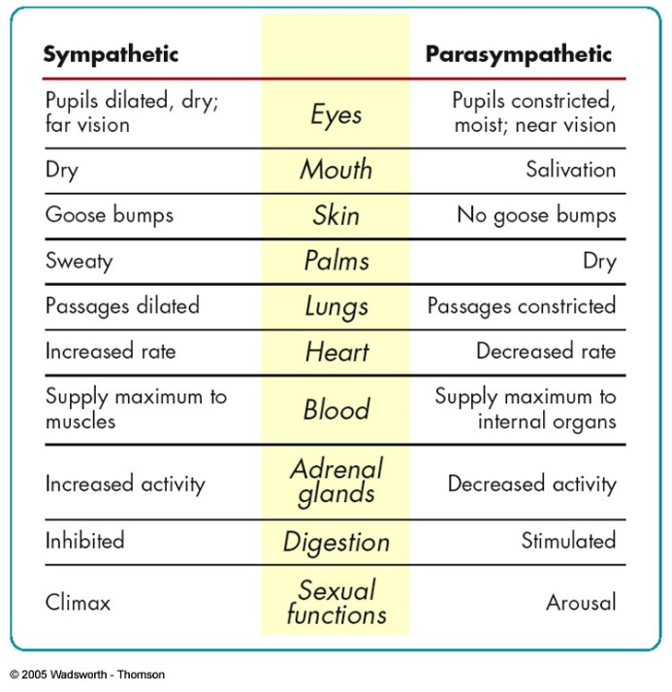
Sympathetic Nervous System
-

-

-

Parasympathetic Nervous System
-
-
-

Homeostasis
-
-
F. Endocrine System
-
Hypothalamus –
Pituitary gland –
Dysfunction:
Posterior pituitary –
Dysfunction:
Anterior pituitary –
Dysfunction:
Pancreas –
Dysfunction:
Thyroid –
Dysfunction:
Adrenal glands –
Dysfunction:

Gonads –
Dysfunction:
G. Research Focus: Sexual Differences
Are There Sexual Differences in the Brain?
-
-
Rotating Figure Problem
-
-
-
Brain Organization
-
-
-
-
H. Cultural Diversity: Racial Myths
Skull Size and Intelligence
-
-
-

Brain Size and Intelligence
-
-
-
What does a positive correlation between brain size and intelligence mean?
-
-
I. Application: Split Brain
What is a Split Brain?
-
-
-
-
How Does a Split-Brain Person Behave?
-
-
-
How Is a Split-Brain Person Tested?
-
-

Do the Hemispheres Have Special Tasks?
Left Hemisphere
-
-
-
Right Hemisphere
-
-
-
How Do Brain Parts Interact?
How is my brain organized?
-
-
Am I “left-brained” or “right-brained”?
-
-
-
Does the brain get better with use?
-
-
-

