Vocabulary #12:

adroit copious
precarious ingenuity
exorbitant nostrum
temerity umbrage
pandemic mischief

1. She was equally adroit in her personal and professional circles.

2. His lead in votes was precarious, though, as several counties had yet to report their numbers.

3. The price is exorbitant for data usage beyond the originally contracted plan.
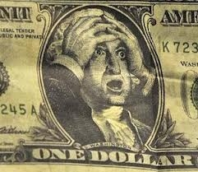

4. She proceeded with her plan, but her temerity meant few would follow her.

5. Cell phone addiction is pandemic and could lead to a generation of poorly educated workers.

6. Good students take copious notes; weaker students note very little.
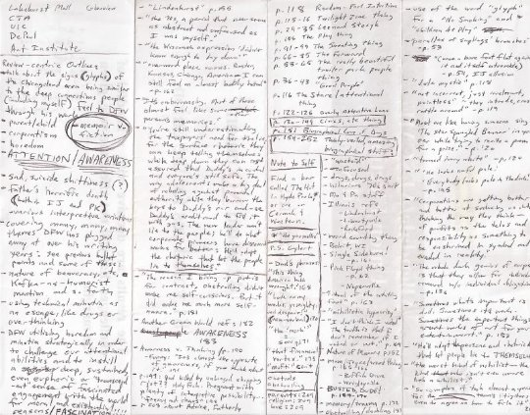

7. Bringing this country out of debt will require ingenuity and responsibility.

8. Politicians present nostrums for problems they create in the first place.

9. He took umbrage at the suggestion that somehow he was at fault for the accident.

10. Tom Sawyer is a literary character known for causing great mischief.

