How to Upload an audio file to Google Slides

1). Take the recording or file and upload to google slides
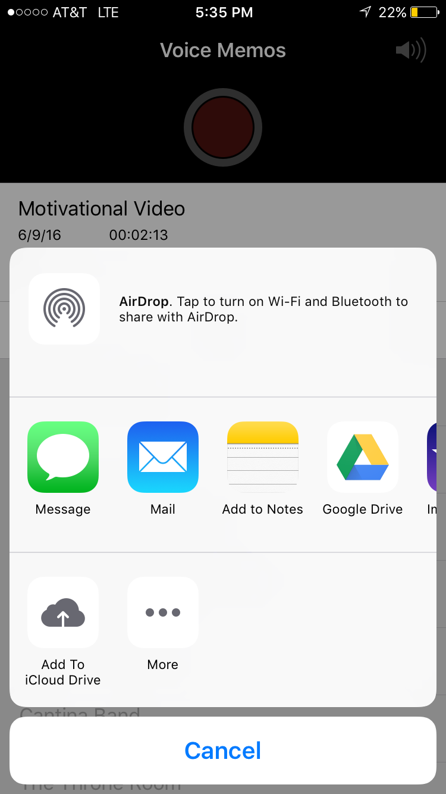

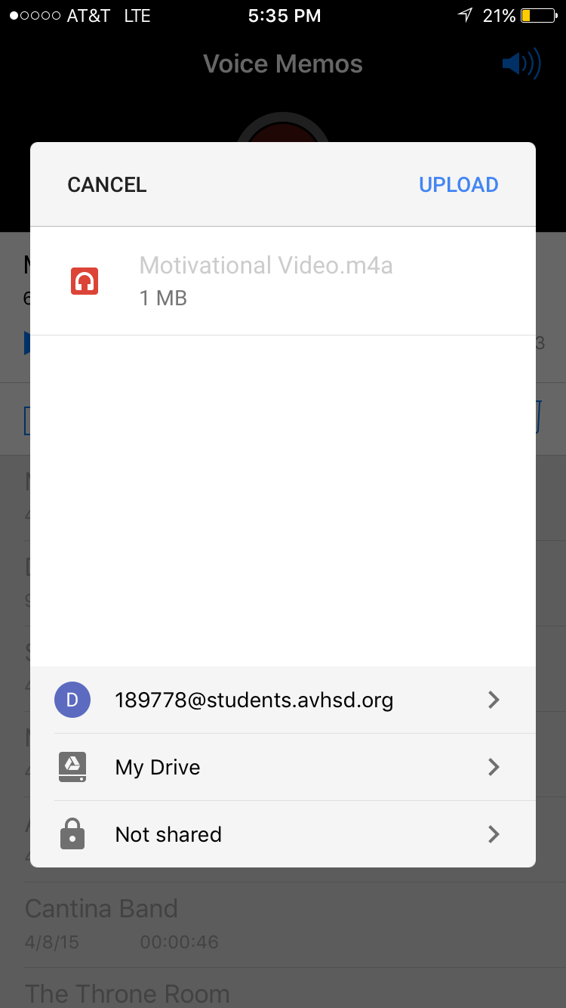
2). Once complete check to make its in google docs

3). Open google slides and open the slideshow you need

4). Go back to google drive and right click the audio file
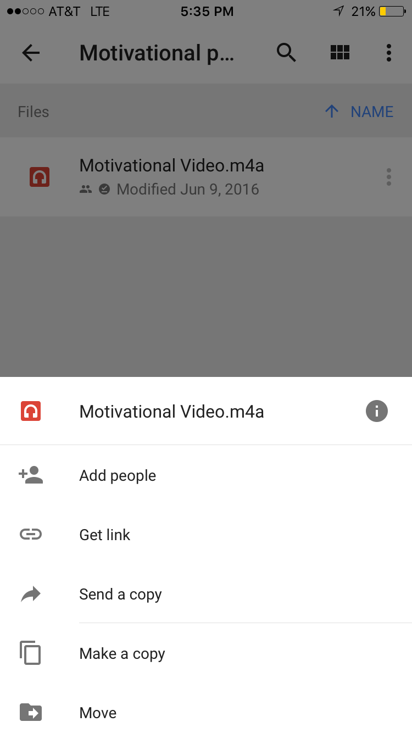
5). Once you have right clicked, click “get sharable link”. It will soon say copied to clipboard which means you have copied the link.

6). Go back to the google slide and right click. Then select “link”
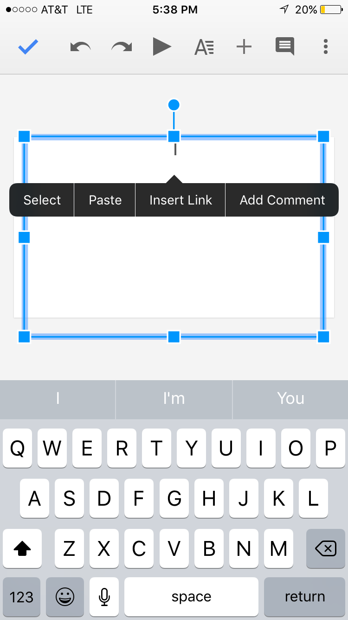
7). It will open a box that shows the name and the hyperlink. Name the hyperlink what you need and below hit control v to paste the link. Select ok. A hyperlink will appear on the slide.
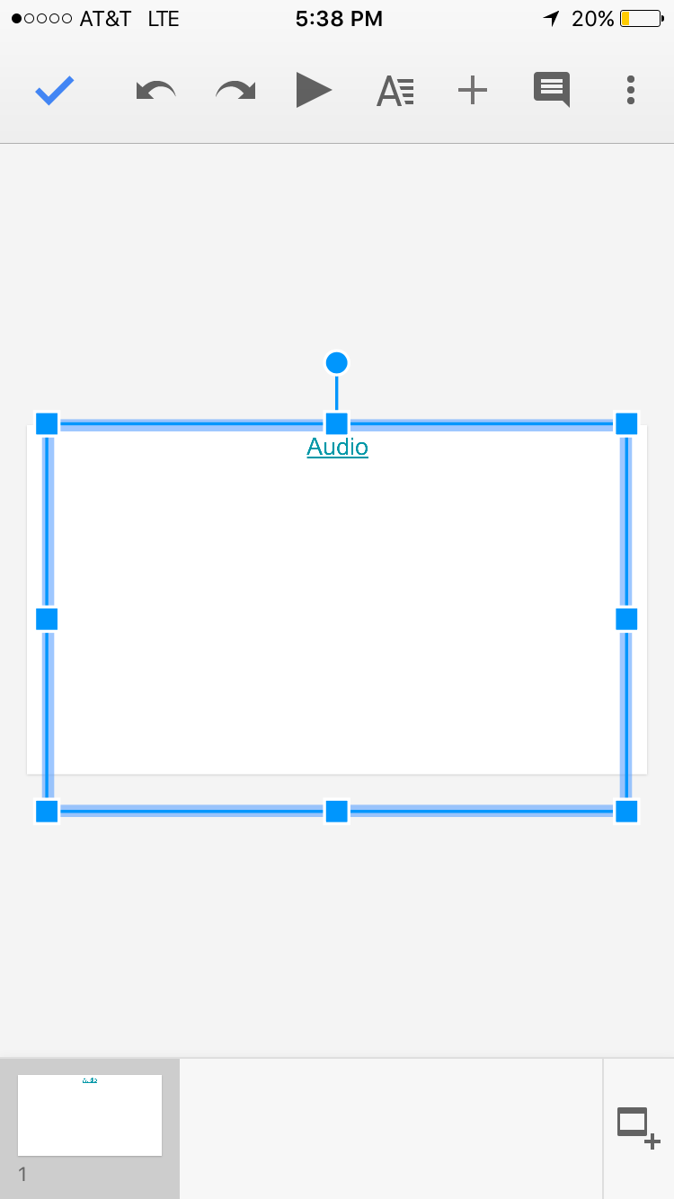
8). Then when presenting the presentation simply click the link. Google docs will redirect you to the audio file and the audio file will play.
