Reading Outline for Plotnik’s Introduction to Psychology, 4th Edition
Module 25 “Social Psychology”

Introduction
Social psychology –

Social cognition –

A. Perceiving Others
Person perception –

How do we form first impressions?
1.

2.

3.

4.

Physical Appearance
What makes a face attractive?

Does an attractive face help?

Stereotypes
-

Development and Kinds of Stereotypes
-

-

-

Prejudice –

Discrimination –

-

Functions and Stereotypes
-

-

Two major functions:
1. Source of information =

2. Thought-saving device –

Schemas
-

Kinds of Schemas
Person schemas –

-

Role schemas –

-

Event schemas –

-

Self schemas –

-

Advantages and Disadvantages of Schemas
-

Advantages –

Disadvantages –

B. Attributions
-

Internal versus External Attributions
Internal attributions –

External attributions –

-

Kelly’s Model of Covariation
-

- Three factors involved:
Consensus –

Consistency –

Distinctiveness –

Biases and Errors in Attribution
-

-
Cognitive miser model –

Fundamental Attribution Error
-

-

Actor-Observer Bias
-

-

Self-Serving Bias
-

-

-

C. Research Focus: Attributions & Grades
Question: Can Changing Students’ Attributions Change Their Grades?
1. Kinds of Attributions
-

-

-

2. Method: Changing Attributions
-

-

-

3. Results and Discussion
-

-

4. Conclusions
-

D. Attitudes
Definition of Attitudes
-

-

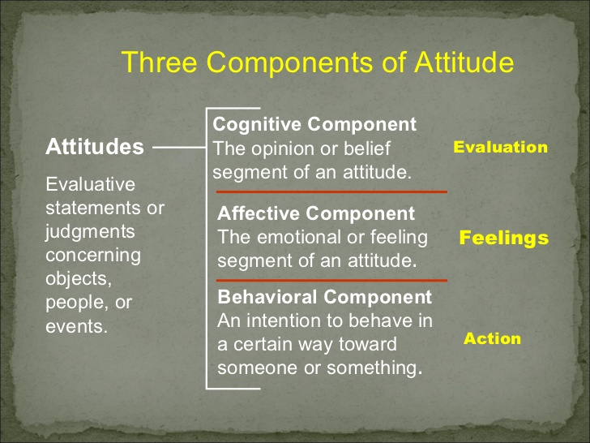
- Many definitions, but all share these features:
-

-

-

Functions of Attitudes
-

-

1. Predispose:
-

-

2. Interpret:
-

-

3. Evaluate:
-

-

Attitude Change
-

Cognitive Dissonance
-

-

-

Self-Perception Theory
-

-

-

Persuasion
Two Routes to Persuasion
Central Route –

-

Peripheral Route –

-

Elements of Persuasion
Source-

Message-

Audience-

E. Social & Group Influences
Conformity
-

Asch’s Experiment
-

Procedure
-

-

Results
-

-

Compliance
-

-

Foot-in-the-door technique –

Obedience
-

Milgram’s Experiment
Would you punish a learner for making errors?
-

-

What would you do if the subject stopped answering?
-

-

Milgram’s Results
-

-

-

-

Why People Obey
-

-

-

Were Milgram’s Experiments Ethical?
-

-

Debriefing -

=

Helping: Prosocial Behavior
-

Altruism –

-

Why People Help
- Three different motivations:
Empathy –

Personal distress –

Norms and values –

Decision Stage Model
-

-
Arousal-Cost-Reward Model
-

-
Group Dynamics and Membership
Groups –

Group cohesion –

Group norms –

Why Do We Form Groups?
-

Motivational reasons
-

-

-

Cognitive reasons
-

-

-

Behavior in Crowds
Social Facilitation and Inhibition
-

=

=

=

Deindividuation in Crowds
-

-

-

-

The Bystander Effect
=

=

=

=

Group Decisions
Group Polarization
-

-

-

-

Groupthink
-

-

-

-

-

F. Aggression
-

-

Aggressive behavior –

-

Model of aggressive behavior –

1.

2.

3.

4.

Biological Factors
-

=

=

=

Social Learning Factors
-

-

-

-

-

Environmental Factors
-

Frustration-aggression hypothesis –

-

-

=

=

=

Modified frustration-aggression hypothesis –

-

-

Sexual Aggression
-
-

-

Kinds of Rapists
-

-

-

-

Rape Myths
-

-

-

G. Cultural Diversity: National Attitudes
What happens when we must like what we hated?
1. Attitudes and Behavior
-

-

-
2. Persuasion
-

-

3. Attitude Change
-

-

-

4. Prejudice and Discrimination
-

-

=

H. Application: Controlling Aggression
Controlling Aggression in Children
-

=

Cognitive-Behavioral Deficits
1.

2.

3.

4.

Program To Control Aggression
1.

2.

3.

4.

Controlling Aggression in Adults
Catharsis
-

=

=

Cognitive-Behavioral Program
-

-

-

Controlling Sexual Aggression
-

-

-

