Inserting YouTube video:
Copy the URL from the video’s page:

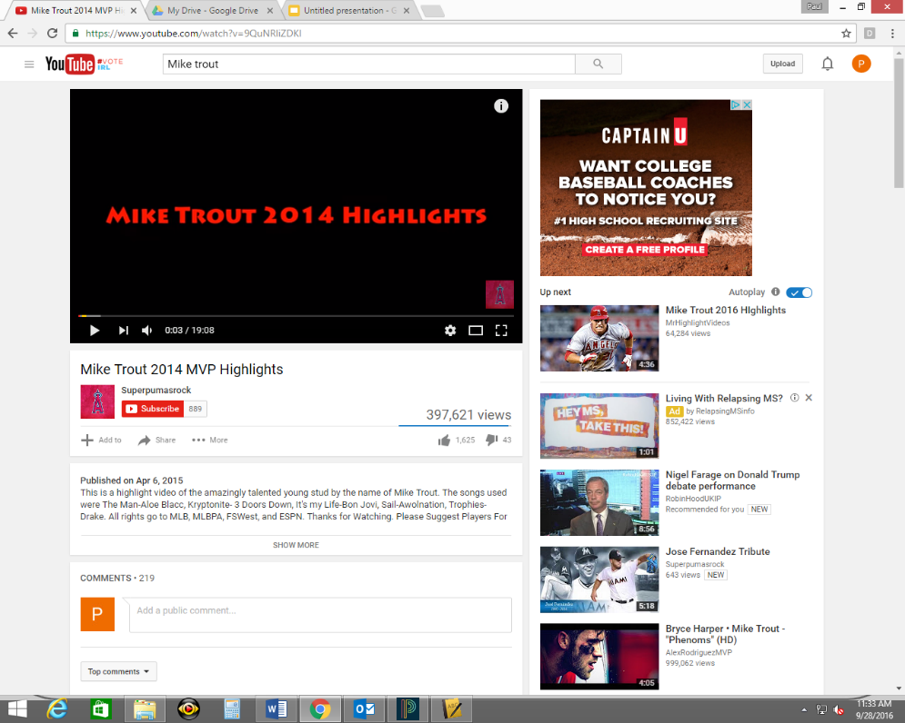

Then in Google Slides, go to insert video:

Next, click on URL and paste the URL from the YouTube video, and click “select”:

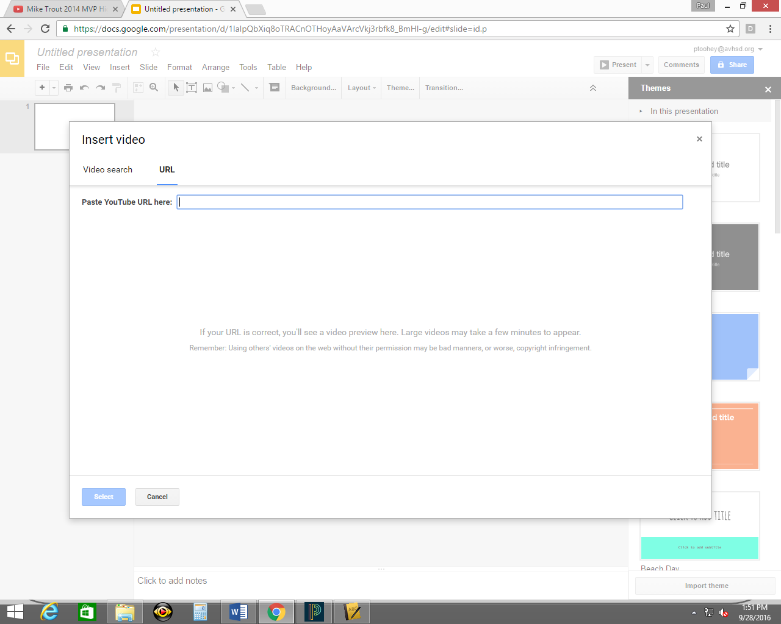
Paste URL here

Double-check that his is the video you want. Click the “present” button to see how it will look in presentation mode:

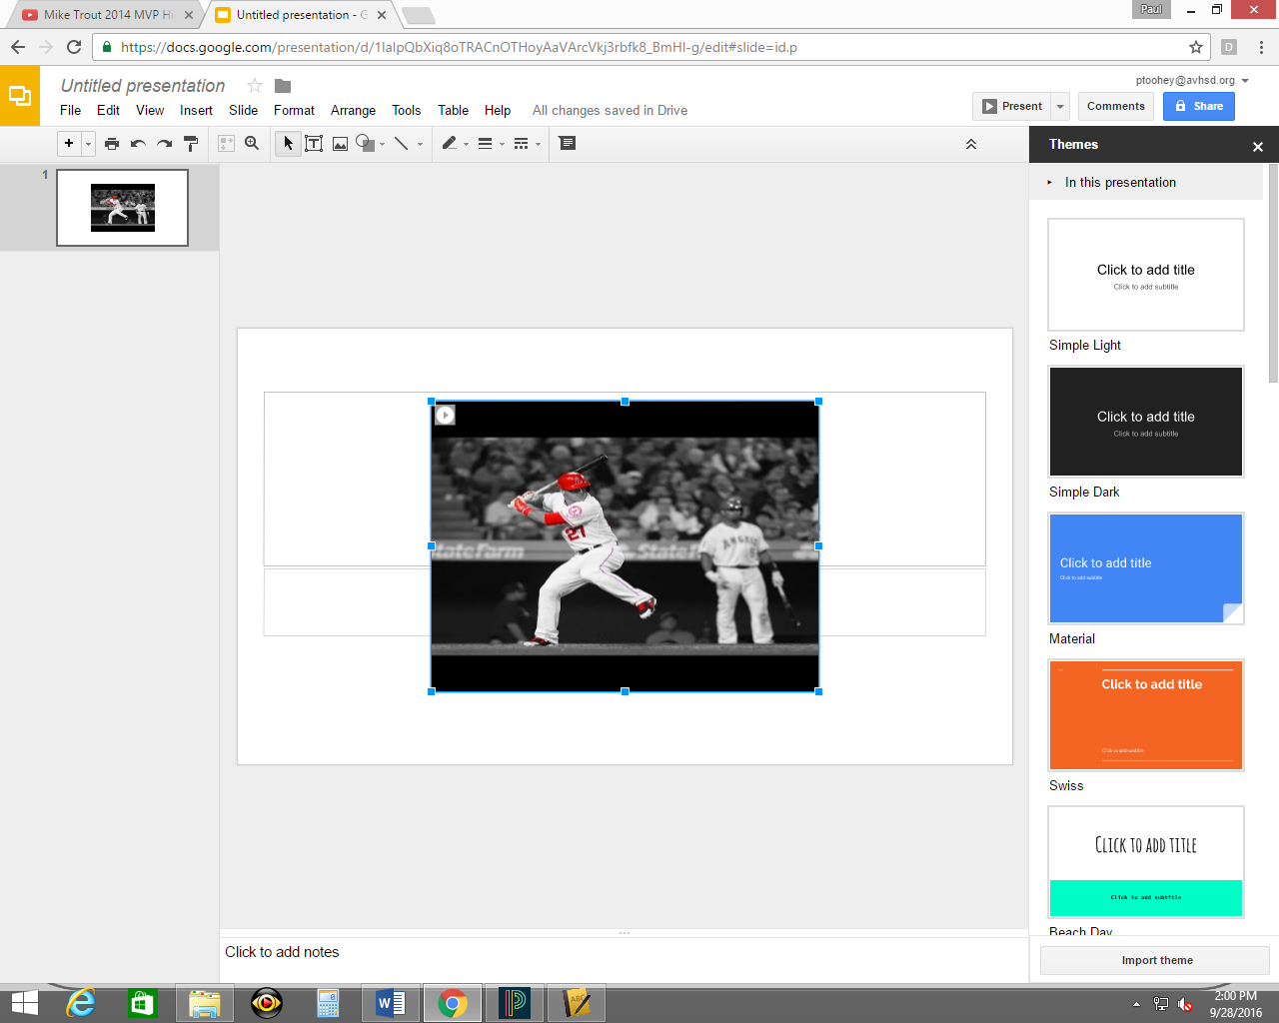

Finished product:

