What to do after the timelines have been completed …

- Create a fact sheet of the information presented in the various group timelines. You’ll be expected to write down a minimum of five pieces of information from each posted timeline (at least one for each of the four themes researched).

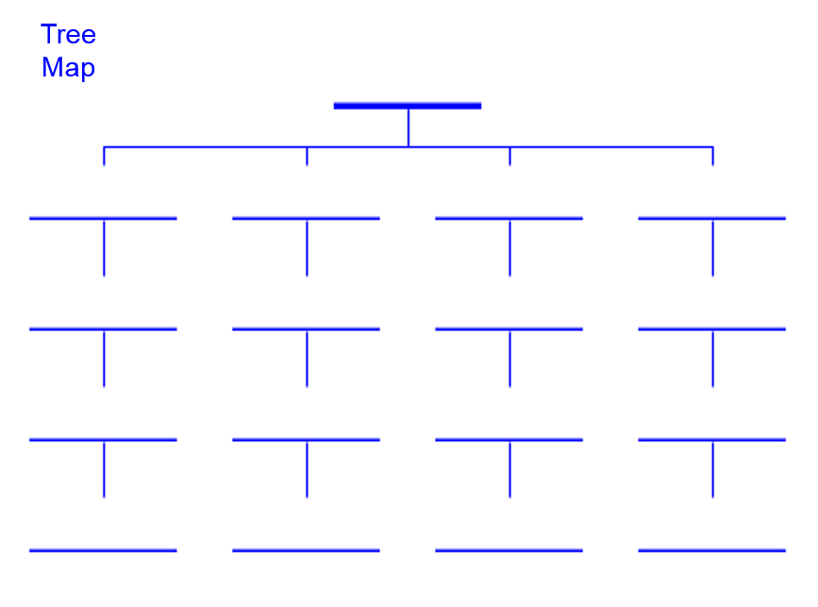
- Create a tree map from the total notes. The title should be something like Preparing for the 20th Century. Then provide four legs (one for each theme), detailing the four or five most significant events of each contributing to the readiness of the U.S. heading into the 20th century. The tree map should look like this:

- Using the tree map as an outline, write a six-paragraph essay describing how the chosen elements of the four themes helped prep the U.S. for the coming century. An example might be that by fighting in four major wars (1812, Mexican-American, Civil, and Spanish-American), the U.S. emerged from the 19th century as a world power, large and strong enough to effect the course of both world wars in the 20th century.

- The fact sheet, tree map, and essay are to be turned in together.

