Directions: In this mini activity packet, you are to do the following:
- Read through the text on the next page and highlight the anything you find interesting. Then, in the space below the reading, specify the top three things you found interesting.
- Complete the wordsearch using the words at the bottom of the page.
- Complete the matching activity using the information in thois packet, your table mates, or the internet to get the various definitions of the terms.
- Color the skull any way you like usig the colored pencils in the group pencil boxes.

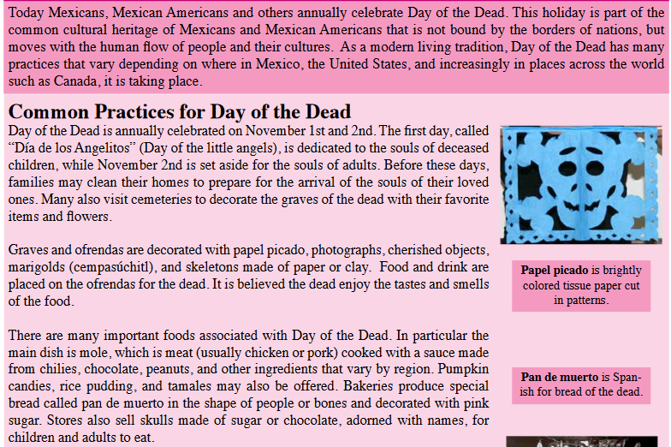

1)

2)

3)

