Reading Outline for Plotnik’s Introduction to Psychology, 4th Edition
Module 5 “Sensation”

Introduction
Three Characteristics of All Senses
1. Transduction
-
-
2. Adaption
-
-
3. Sensations
-
-
- Eye: Stimulus, Structure, & Function
Wavelengths – What’s visible and what isn’t?
Invisible – too short
-
-
Visible – just right
-
-
-
Invisible – too long
-
-
What happens when you see a giraffe?
1. Light waves.
-
-
-
2. Image reversed.
-
-
3. Cornea.
-
-
4. Pupil.
-
-
5. Iris.
-
-
-
6. Lens.
-
-
-
7. Retina.
-
-
-
8. Eyeball.
8a. Normal vision -
8b. Nearsighted -
8c. Farsighted -
Retina: A Miniature Computer
The process of transduction
1.

2. Rods

3. Cones

4.

5.

Visual Pathway: Eye to Brain
- Retina.

- Optic nerve.

- Primary visual cortex.

- Association area.

- Information processing.

- Stimulation or blindness.

Color Vision
Making Colors from Wavelengths
1.

2.

3.

The Trichromatic Theory –

-

-

Opponent-Process Theory –

-

-

The theories combined
-

-

-

Color Blindness
-

Monochromats –

Dichromats -
B. Ear: Stimulus, Structure, & Function
Stimulus: Sound Waves
-
-
Relationship: Amplitude and Loudness
-
-
-
Relationship: Frequency and Pitch
-
-
-
Decibel Levels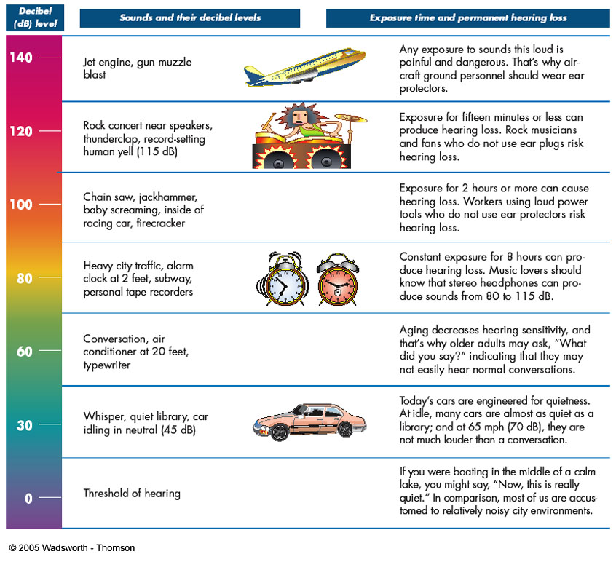
Hearing or Auditory System
- Outer Ear.
-

-

1a.

1b.

- Middle Ear.
-

-

-

- Inner Ear.
-

-

3a.

3b.

3c.

- Brain: Auditory areas
-

4a.

4b.

Information from Sound Waves
Judging Direction
-

-

-

Judging Pitch
-

-

-

Judging Loudness
-

-

-

C. Vestibular System
-
-
Motion Sickness
-

-

-

-

Meniere’s Disease and Vertigo
-

-

-

D. Chemical Senses: Taste and Smell
Taste –

- Four basic tastes.
-
-

2. Surface of the tongue.
-

-

3. Taste buds.
-

-

-

4. All tongues are not the same.
-

-

-

5. Taste and Smell
-

-

-
Smell or Olfaction –

-

1. Stimulus.
-

-

2. Olfactory Cells –

-

-

3. Sensations.
-

-

-

Functions of Olfaction
-

-

-

E. Touch: Stimulus, Structure, & Function
-

-

Skin
-

-

Hair receptors
-

-

-

-

Free nerve endings
-

-

-

Pacinian corpuscle
-
-

Brain Areas
-

-

-
F. Cultural Diversity: Different Tastes
-

-

-

G. Research Focus: Pain & Placebos
Research Question: Does the Mind Make Pain Go Away?
-

-

-

-

-

-
H. Pain: A Different Sense
-

-

-

Gate Control Theory
-

-

-

-

Is Pain Purely Physical?
-

-

Endorphins
-

-

-

-
Acupuncture
-

-

-

-

I. Application: Artificial Senses
Artificial Visual System
-

-

1. Eye and retina.
-

-

-

2. Brain Implant.
-

-

3. Functional vision.

Artificial Hearing System
-

Conduction Deafness
-

-

-

Neural Deafness
-

-

-

How Well Do Cochlear Implants Work?
-

-

-

