Close Reading Directions: Ezra Pound’s “In a Station of the Metro”:

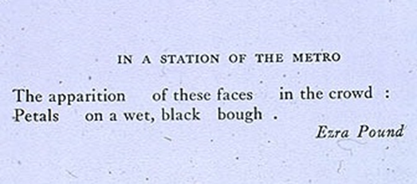

Choose TWO of the “steps” below examining the poem, above.

STEP 1:
- Summarize the passage and provide a basic context for that passage. Look at basic elements of word choice, punctuation, etc., to help you understand.

STEP 2:
- Examine the imagery of the passage.
- What stands out to you? Why?
- Are there things that echo earlier parts of the story or foreshadow later parts (think of poetic refrain)?
- Are there images that seem to compact larger themes into dense moments (think of microcosm)?
- Are there words images that are puzzling? Think them through, and see what you can make of them with the information immediately surrounding. When you have seemingly exhausted the possibilities, then move beyond the bounds of your passage to the story at large.

STEP 3:
- Examine the setting of the passage.
- Where is the passage taking place?
- How does the physical setting affect the action of the story? Does it amplify the action?
- Does it seem to confound the overt narrative?
- Are the peculiarities to the physical context? Are there things you did not notice the first time through?
- How might paying attention to all of this help us to make sense of the story?

STEP 4:
- Examine the dialogue (if there is any) in the passage.
- Who is speaking? To whom are they speaking?
- What is the speaker hoping to accomplish in this moment? What tact(s) does he or she take to accomplish that / those goal(s)?

STEP 5:
- Carefully consider the tone of the passage.
- What does this particular passage feel like? Where does that feeling come from?
- Is the tone primarily created by diction? By action? By character?
- What import does the tone have on the story?
- Does it fit in with what surrounds it?

